**Scope Management - Webpage Development**

Lauren Alexandra

Colorado State University Global

CSC 501: Management for the Computer Science Professional

Dr. Charles Lively

April 29, 2021

**Introduction**

A 3D printer company is deploying a new customer-facing webpage highlighting their different 3D printing products in addition to filaments and spools. To produce the webpage, the project management team must develop a scope management plan for product deployment and account for all inputs and tools involved. The team must also decide on a project lifecycle as well as a development approach to best execute a secure webpage that meets stakeholders’ expectations.

**Scope Management**

Project plans not only define scope, but also outline how scope will be generated and supervised (Siegel, 2019). A few integral elements are necessary for this project’s scope management plan: the project charter, the project management plan, and knowledge of enterprise environmental factors and company process assets (Project Management Institute, 2017). The charter is a declaration of the webpage project that details the criteria, germinal requirements and deliverables, risk, milestones, stakeholders, and financial resources, and assigns a project manager, granted the authority to utilize company resources. The webpage project management plan establishes the elemental project cost, time, and scope. These references will be later refined. The plan encompasses stakeholder engagement in addition to resource, risk, and communications management. Furthermore, the plan describes the project life cycle and development approach. Factors such as the company culture, policies, and administration, the current website support, and competitors’ actions also influence scope creation. Lastly, personnel sourced from previous website updates and consulted web experts will shape scope.

As a result of this planning process, both a scope and a requirements management plan will be assembled (see Figure 1). Project members empowered by agreed upon processes can then form a scope statement and know how scope will be maintained through the duration of the project. Procedures for how the webpage requirements will be tracked and modified enable developers to meet the deliverables.

**Figure 1**

*Scope Management Deployment*

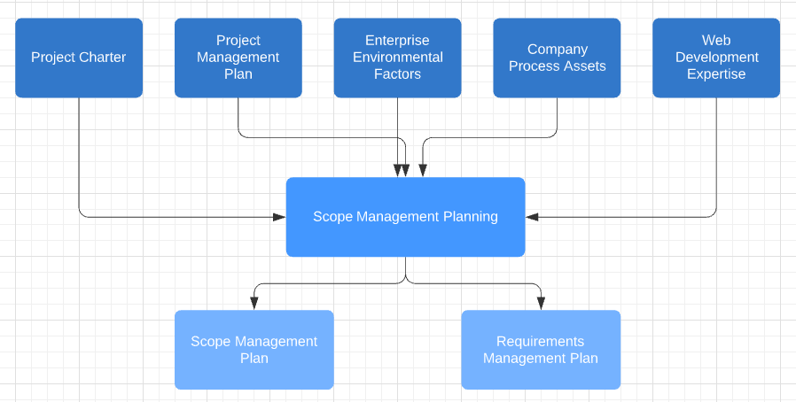

*Note.* Created in <https://lucid.app>.

**Lifecycle and Development**

For this project the team will apply an iterative lifecycle. To develop the webpage the team will adhere to Agile development specifically employing Scrum methodology. The lifecycle will allow the engineering team to build the webpage across iterations and receive feedback sooner. As the team completes sequential deliveries, they will learn faster about the product.

Agile is an approach to project management that ensures requirements are met throughout the lifecycle in incremental phases. Teams that follow Agile embrace failure in the execution phase, relying on quick cycles and frequent customer interaction to allow for early corrections, and fixate on delivering results in the form of working software (Gheorghe et al., 2020).

Scrum involves short work periods or sprints that consist of a small number of activities. The framework manages changes in scope through the use of a product owner and a product backlog. The product owner is responsible for manifesting the project’s value by prioritizing items to be included in each sprint from the product backlog. The backlog maintains a collection that describes the product’s features. Simultaneously, the product owner directly interfaces with stakeholders whenever they request project changes. Engineering teams that respect the product owner’s authority will be able to concentrate on technical excellence, adapt to mutable requirements, and shield against competing external change requests.

**Security**

The risks posed by web vulnerabilities need to be considered to create a secure webpage. The webpage project team should pay close attention to cross-site scripting (XSS), cross site request forgery (CSRF), misconfigurations, data exposure, and using software with known vulnerabilities (OWASP, n.d.). A failure to properly sanitize user inputs invites XSS. To prevent this attack HTML tags should not be returned to the client. A CSRF attack on the other hand targets a user’s session; this can be thwarted with a secret token hidden from third parties. Finally, engineers must be mindful of guarding sensitive data and limiting the use of flawed libraries and frameworks where possible.

**Conclusion**

The scope of the customer-facing webpage will be controlled through a scope management plan, a strategic lifecycle, and proactive web safety measures. By preparing to manage scope during the project lifecycle, the team can commit to delivering value within the project expectations. Additionally, with a product owner at the helm, engineers do not need to conference with stakeholders on modifying requirements during development, but can instead focus on generating a secure, quality product.

**References**

Gheorghe, A., Gheorghe, I.D., & Iatan, I.L. (2020). Agile Software Development.

*Informatica Economica, 24*(2), 90-100.

Open Web Application Security Project. (n.d.) *OWASP Top Ten.*

[https://owasp.org/www-project-top-ten](https://owasp.org/www-project-top-ten/)

Project Management Institute. (2017). *A Guide to the Project Management Body of*

*Knowledge*. Project Management Institute.

Siegel, N. G. (2019). *Engineering Project Management.* John Wiley & Sons Ltd.